**Name : Davinder Verma**

**Group no: 4**

**Student No:- 121802201**

**Prof Name:- Azer Karadag**

**Date:- 23/03/2021**

**Work:- Sales and Scheduling Test answer sheet**

**Sales and Scheduling Test**

**Question 1 (worth 5 marks)**

Create a class diagram that supports the scenario.

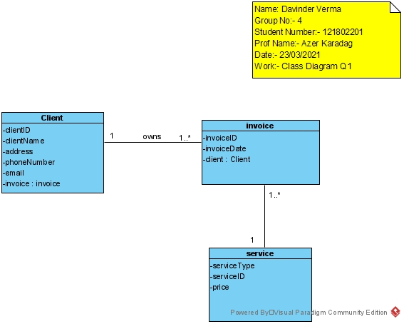

**Question 2 (worth 10 marks)**

Complete sequence diagrams to support the above scenario.

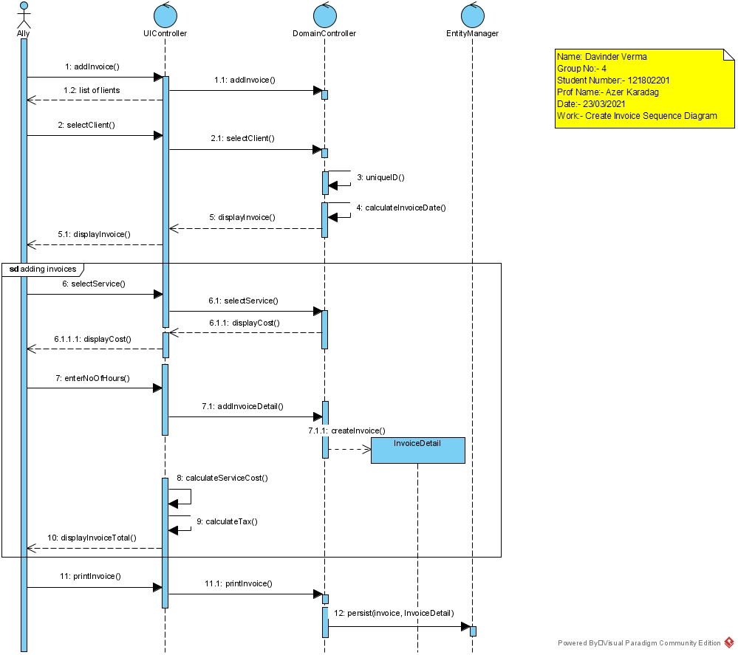

**Question 3 (worth 2 marks)**

The above scenario assumes that the cost/hour for a service is the same for each employee. What would happen if the cost/hour changed for each employee providing the service? How would you change your model? Please describe in English.

**I will add a new sequence in which I will as the user selects service they will have a option to update the service cost. So, if there are any changes to the rate they will be able to change.**

**Question 4 (worth 2 marks)**

*Ally Cares* is thinking of offering a 10% discount to their clients who recommend their services. How would you change your model to support this?

**After the step 8 in the above sequence diagram, I will ask the user for applying the 10% discount if the client has recommend us. The discount will be calculated before the tax and the HST will be calculated after all the discounts are applied.**

**Question 5 – Class Diagram (worth 10 marks)**

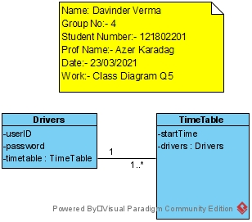

**Question 6 – Sequence diagram (worth 5 marks)**

Please complete an object level sequence diagram to support the above scenario.

